(Title of paper in font Times New Roman 14pt in bold)
First author, second author … (corresponding author is specified by *, font Times New Roman 12pt in bold)
- Academic rank, main specialty, department, faculty, university \ research institute - e-mail address (Times New Roman 11pt)
- Academic rank, main specialty, department, faculty, university \ research institute - e-mail address (Times New Roman 11pt)
.
.
.
The full paper should have the following main components in order:
- Abstract
- Introduction
- Materials and Methods
- Results and Discussion
- Conclusion
- References
- Abstract (in Persian)
Abstract (Times New Roman 12pt in Bold)
Each paper should include an abstract that has been composed maximum of 250 words in one paragraph. This section should independently explain the summary of subject, aims, research method of the article's results. Citing the references must be avoided in this section. The font to this section is (Times New Roman 11pt).
Keywords: Contains a minimum of 5 and a maximum of 6 words separated by commas and arranged alphabetically in one line. (Times New Roman 11pt)
1. Introduction (Times New Roman 12pt in Bold)
Writing papers requires word software (preferably Office version 2013) in windows, and A4 paper is needed. In preparing the main text consider using the (Times New Roman 12pt) font and single line spacing. Set the space between paragraphs in automatic (Auto) mode. The text of the paper should be provided with margins of 35 mm from the upper and left edges and 25 mm from the bottom and right edges. The title of each section uses the font (Times New Roman 12pt in Bold) with the number of sections, and a spacing with a blank line, from the previous section. The subtitles should be written with the font (Times New Roman 11pt in Italics), with the same order. The first line of all paragraphs should be indented 5 mm. Punctuations like dots, commas, etc. must be properly used.
2. Submission
All full papers will be evaluated by the conference jury. For this reason, it is necessary to the text file to be prepared according to the terms of this document and submitted with the .doc and .pdf format via conference's users system in the website. Secretariat excuses submissions that are not provided with these formats. In case of facing with any problem while submitting share with the secretariat of the conference via the address info@events.uma.ac.ir/agri The state of acceptance of the paper will be informed to the corresponding author which has recently been specified with an asterisk in the list of authors. However the status of articles can be followed via the website of the conference https://events.uma.ac.ir/agri When the paper is accepted, it is necessary for the authors of the article to apply the corrections requested by the referees in the requested time frame and re-send the final version via the conference's website.
3. Length of the paper
The article should be 5 to 10 pages Length, including all sections such as figures and tables.
4. Mathematical Equations, figures, and tables
1-4- Equations and formulas
All equations and formulas should be written in the middle of the line (center alignment) and with a font size appropriate to the text. The number of each equation / formula should be mentioned in parentheses at the end of the right side. Consider the following example as a model:
$\overline{R}= \frac{\sum{n}}{\sum{Dn}}$ (1)
Where $\overline{R}$ is Average germination rate, D is day number from the beginning of the germination test, n is the number of germinated seeds per day.
2-4- Figures and Tables
All figures and tables should be included in the text and the closest place to the first mention in the context. Figures and tables will be placed in the middle of the lines (center alignment). Figures must have sufficient resolution and be so-called: high quality. Letters, signs and titles must be legible and chosen in a size that is separable and selected. If you are including tables, it is essential to identify the quantity and unit of each axis in the figure. Each figure or table contains a sequence number which is independent and has to be mentioned inside the text. Also each figure or table contains an independent caption which should be written below or above the table with the font (Times New Roman 10pt in Bold). If the figure or table of the research is not ready yet, and if it is taken from a specific reference, the number of reference has to be mentioned in brackets at the bottom of the figure or the table. For instance see table 1 and figure 1 and 2 as below:
Table 1- Populations of Trichoderma harzianum isolate T22, recovered from rhizosphere soil of hairy vetch plants after final harvest
Treatment combinations§ | Mean population¶  (Log CFU/g fresh root)
0P (control) | 4.15 ± 0.32 c
11P | 4.35 ± 0.69 c
22P | 4.90 ± 0.44 bc
B-0P | 5.26 ± 0.94 b
B-11P | 6.24 ± 0.79 a
B-22P | 6.10 ± 0.28 a
§ Three levels of P supplementation without and with biochar application assigned as [0P, 11P and 22P] and [B-0P, B-11P and B-22P], respectively.
¶ Data represent the average of three replicates (n= 3) ± standard error. Means followed by the same letter are not significantly different according to Fisher’s protected LSD (P≤ 0.05).
Fig. 1- Effects of biochar and Trichoderma on root volume, leaf MDA content (A) and CAT and POX activity (B). Effects of biochar and P supplementation on POX activity (C) and soil Olsen-P (D). Means ± S.E. Columns followed by the same letter are not significantly different according to Fisher’s protected LSD (P≤ 0.05). NS, * and ** denote non-significant and significant at 5 and 1% levels, respectively. CV represents coefficient of variation. MDA malondialdehyde; CAT catalase; POX peroxidase; FW fresh weight

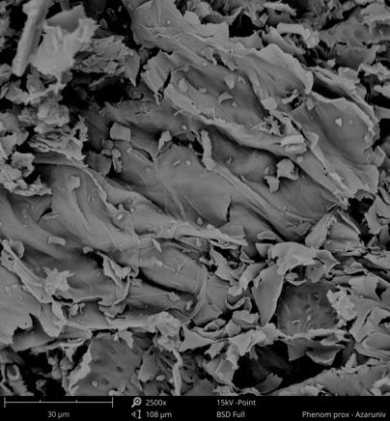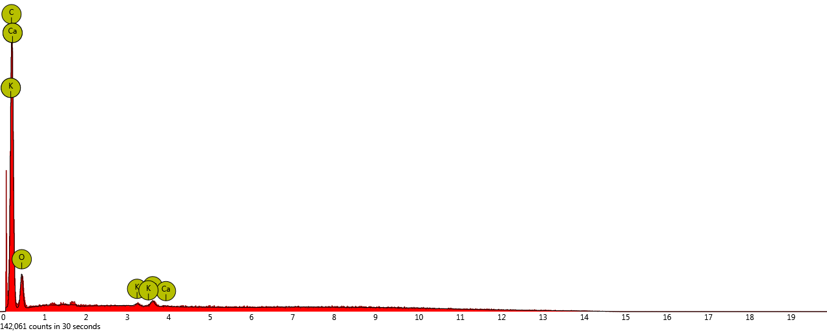
Fig. 2- SEM - EDX analysis of biochar sample prepared from peanut hulls
5. Units
Standard units SI system is the only acceptable system for the scheme of the issues. Note that the units for the amounts listed in tables and axes titles in shapes should not be forgotten.
6. Footnotes
If using footnotes is inevitable, use the font Times New Roman 10pt.
7. Conclusion section
Each Paper should be provided with a summary of the research results presented in the article at the end of the context as the conclusion section. Possible recommendations are also presented in this section.
8. Acknowledgement (optional)
If necessary, a brief appreciation can be mentioned before the list of references.
References
The reference list section is the last part of the article, which is not assigned a title number. References and sources are given in alphabetical order in this section. Mentioning of each reference in the text is based on author-year system. The font size used for Persian references (B Nazanin 11pt) and for English references will be the same as other parts of the article with a smaller size (Times New Roman 10pt). After typing each reference, a space of 6 pt with the next reference is required. The specifications of each reference must be presented in a complete and standard manner according to the APA sixth edition style (available in the References menu in Word version 2013).
For example:
DOE, (2022, June 10). Permissible limits of soil pollution and pollutants entering it (According to the soil protection law). Organizational standards. Retrieved July 30, 2020, from https://wsm.doe.ir/portal/home/?673823
Friedlova, M. (2010). The influence of heavy metals on soil biological and chemical properties. Soil and Water Research, 5(1), 21-27. doi:10.17221/11/2009-SWR
Ghosh, P., & Das, S. P. (2022). Unraveling a dynamic ameliorant of heavy metal-polluted soil: Biochar. In R. T. Kapoor, & M. P. Shah, Biochar: Applications for bioremediation of contaminated systems (pp. 163-184). Berlin: Walter de Gruyter GmbH & Co KG.
Gonzaga, M., de Jesus Santos, J., Ganassali Junior, L., Fontes, P., A. J., & Gonzaga, T. (2022). Copper uptake, physiological response, and phytoremediation potential of Brassica juncea under biochar application. International Journal of Phytoremediation, 24(5), 474-482. doi:10.1080/15226514.2021.1954875

(عنوان با فونت B Nazanin 16pt پررنگ)
مولف اول¹*، مولف دوم²، ... (نویسنده مسئول با * مشخص شود، فونت B Nazanin 12pt پررنگ)
1- مرتبه علمی، تخصص اصلی، گروه آموزشی، دانشکده و دانشگاه / موسسه علمی - پژوهشی، (B Nazanin 10pt ) - آدرس پست الکترونيکي
2- مرتبه علمی، تخصص اصلی، گروه آموزشی، دانشکده و دانشگاه / موسسه علمی - پژوهشی، (B Nazanin 10pt ) - آدرس پست الکترونيکي
.
.
.
چكيده (B Nazanin 12pt پررنگ)
هر مقاله بايد داراي يک چكيده حداکثر 250 کلمهاي باشد که در يک پاراگراف تهيه شود. اين بخش بايد به صورت مستقل بيانگر خلاصهای از موضوع، اهداف، روش تحقيق و نتايج مقاله باشد. از اشاره به منابع و مآخذ در اين قسمت بايد خودداري شود. فونت اين بخش از نوع (B Nazanin 11pt) ميباشد.
واژه‌هاي كليدي: حداقل 5 و حداكثر 6 واژه كه با ویرگول جدا شده و بر اساس حروف الفبا در يك خط قرار گيرند. (B Nazanin 11pt)

